
PREdictive Modelling
Project Assignment- Question 2 (Holiday Packaging)

March 10, 2021
Priyanka Pravinkumar Sukre
April’21 Batch

Contents
Logistic Regression and LDA: 2
2.1 Data Ingestion: Read the dataset. Do the descriptive statistics and do null value condition check, write an inference on it. Perform Univariate and Bivariate Analysis. Do exploratory data analysis. 3
2.2 Do not scale the data. Encode the data (having string values) for Modelling. Data Split: Split the data into train and test (70:30). Apply Logistic Regression and LDA (linear discriminant analysis). 11
2.3 Performance Metrics: Check the performance of Predictions on Train and Test sets using Accuracy, Confusion Matrix, Plot ROC curve and get ROC_AUC score for each model Final Model: Compare Both the models and write inference which model is best/optimized. 13
2.4 Inference: Basis on these predictions, what are the insights and recommendations. 19

List of Tables:

S No | Table | Description
1 | Table 2.1 | Sample Dataset
2 | Table 2.2 | Info
3 | Table 2.3 | Null Values
4 | Table 2.4 | Statistical Summary of Dataset
5 | Table 2.5 | Categorical Analysis
6 | Table 2.6 | Foreigner Vs Holiday package
7 | Table 2.7 | Encoded Statistical Dataset
8 | Table 2.8 | Train and Test Data dimensions
9 | Table 2.9 | Confusion Report on Train data_logistics
10 | Table 2.10 | Confusion Report on Test data_logistics
11 | Table 2.11 | Confusion Report on Train data_LDA
12 | Table 2.12 | Confusion Report on Test data_LDA

List of Figures:

S No | Figures | Description
1 | Fig 2.1 | Distribution Plots
2 | Fig 2.2 | Box Plots
3 | Fig 2.3 | Education Vs Holiday package
4 | Fig 2.4 | No_young Children Vs Holiday package
5 | Fig 2.5 | No_older_children Vs Holiday package
6 | Fig 2.6 | Salary Vs Holiday package
7 | Fig 2.7 | Age Vs Holiday package
8 | Fig 2.8 | Correlation
9 | Fig 2.9 | Sample Pair plot
10 | Fig2.10 | AUC_Train_Logistics
11 | Fig 2.11 | AUC_Test_Logistics
12 | Fig 2.12 | AUC_Train & Test_LDA

Logistic Regression and LDA:

Problem 2:
You are hired by a tour and travel agency which deals in selling holiday packages. You are provided details of 872 employees of a company. Among these employees, some opted for the package and some didn't. You have to help the company in predicting whether an employee will opt for the package or not on the basis of the information given in the data set. Also, find out the important factors on the basis of which the company will focus on particular employees to sell their packages.
Data Dictionary:
Variable Name | Description
Holiday_Package | Opted for Holiday Package yes/no?
Salary | Employee salary
age | Age in years
edu | Years of formal education
no_young_children | The number of young children (younger than 7 years)
no_older_children | Number of older children
foreign | foreigner Yes/No

2.1 Data Ingestion: Read the dataset. Do the descriptive statistics and do null value condition check, write an inference on it. Perform Univariate and Bivariate Analysis. Do exploratory data analysis.

To start with the analysis let us start understanding the data
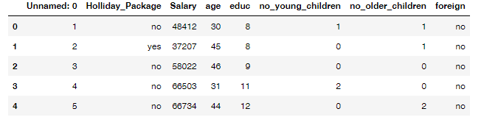
Table 1.1: Sample Data Set

- The dataset has a total of 7 variables with 5 continuous variables, two categorical type variables and one variables of Serial Number.
- Shape (Dimension of the dataset is 872, 6)
- Info of the data set is as below:
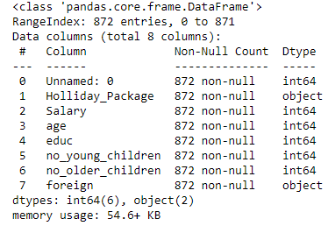
Table 1.2: Info

- There were “Zero” null values present in the Dataset variables.
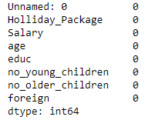
Table 1.3: Null Values

- Duplicate Values: There are no duplicate values.
- Univariate Analysis: To perform the Univariate analysis, let us start with looking at the summary of the dataset:
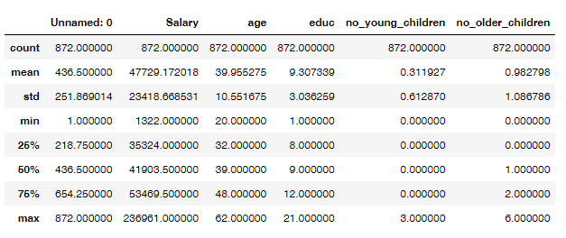
Table 1.4: Statistical Summary of the Dataset
- Inferences:
- There is a huge variance in the salary as the minimum salary is 1322 and the maximum salary is 236961 and also having high standard deviation.
- The minimum age is 20 and the maximum age is 62.
- The maximum years of formal education is stands at 21 while minimum at 1.
- 75 % employees have neither younger or older children.

Distribution Plots:
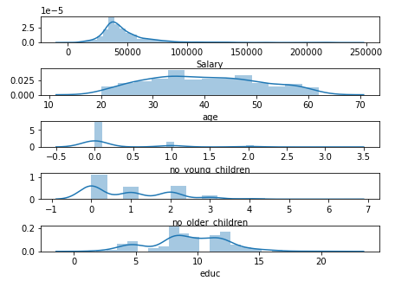
Fig 2.1 Distribution plots
Box Plots
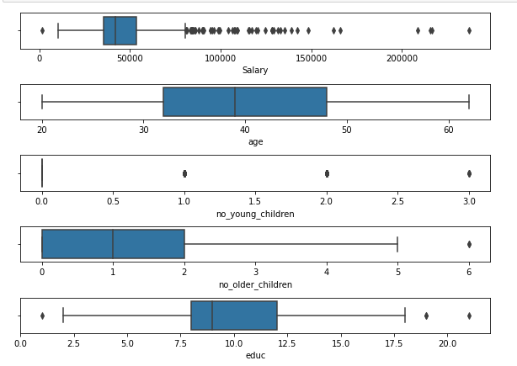
Fig 2.2 Box plots
Inferences:
- Salary is right skewed with high dispersion
- There are outliers present in the salary which is normal with the variable like salary.
- Age is very close to normal distribution with no outliers present.
- Education is showing multimodal density plot
- Education is showing very low presence of outliers which is acceptable.
- With the above inferences in this particular case the outliers are not being treated
Categorical variable Analysis:
Inferences of Categorical Variables:

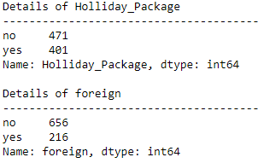
Table 1.5: Categorical analysis
- Almost 46 % of employees opted for holiday package.
- Almost 24% are of foreigners

Bivariate Analysis:
Years of Education Vs Holliday Package (Fig 2.3)
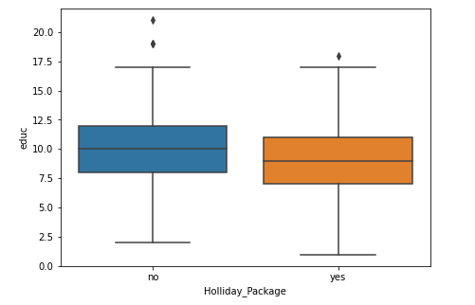
No_Young_Chindren Vs Holliday Package (Fig 2.4)
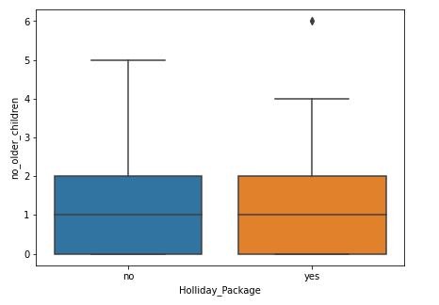
No_Older_Chindren Vs Holliday Package (Fig 2.5)
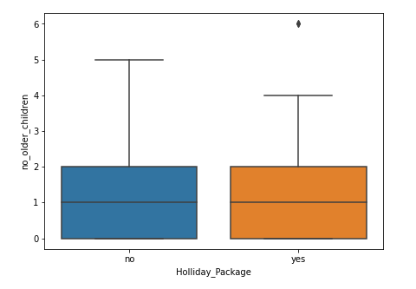

Salary Vs Holliday Package (Fig 2.6)
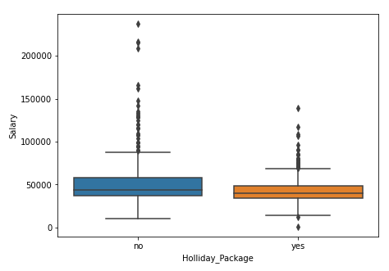
Age Vs Holliday Package (Fig 2.7)
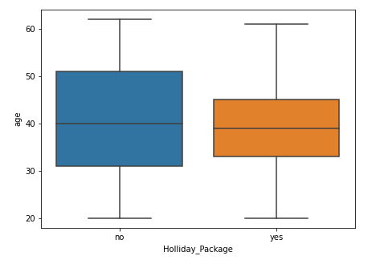
Foreign Vs Holliday Package (Table 2.6)
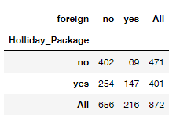

Inferences:
- There is no big influence of these variables in target variable
- 147 foreigners opt for taking the Holliday Package which is around 16%

Correlation:

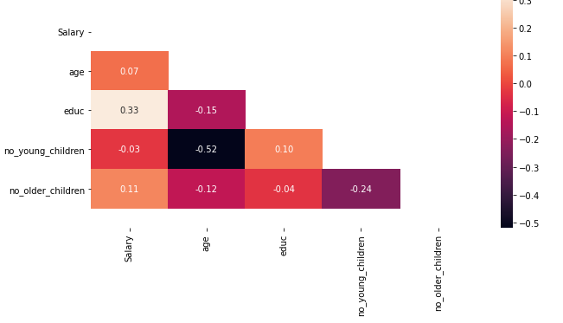
Fig 2.8: Correlation
Inferences:
- No high correlation among the variables and there will be no impact on the target variable.

Sample Pair plot:
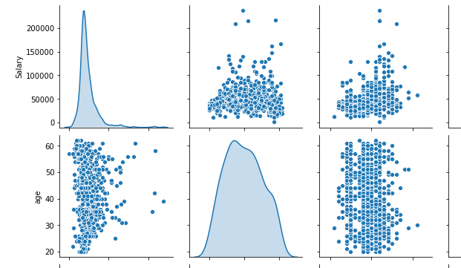
Fig 2.9: Sample Pair plot

- It is evident that none of the variables are strong predictor of target variables individually as there is no positive or negative correlation among the variables
2.2 Do not scale the data. Encode the data (having string values) for Modelling. Data Split: Split the data into train and test (70:30). Apply Logistic Regression and LDA (linear discriminant analysis).
From the dataset it is evident that, we have two categorical values Holliday Package and Foreigner variables. To perform the regression models we need to encode the categorical variables.
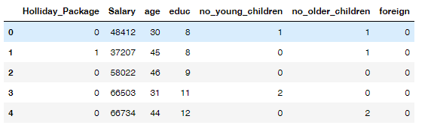
Table 2.7: Encoded Statistical Dataset
The sample dataset after encoding the categorical variables is above.
Train and Test Data:
From the dataset the train and test data is divided into two subsets with 70:30 ratio.
- Train Dataset: Used to fit machine learning model
- Test Dataset: Used to evaluate the fit machine learning model.
- The train test data is basically used when the dataset is large.
- There is no class imbalance in the dataset.
Below is the train test data from the dataset:
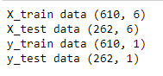
Table 2.8: Train and Test Data
- Model Scores
  - Logistics Regression Model Score on Train Data is: 0.678.
  - Logistics Regression Model Score on Test Data is: 0.637.
From these two scores we can say that, the model is performing well have does not have over fir or under fit. The model has a good fit on train data.

2.3 Performance Metrics: Check the performance of Predictions on Train and Test sets using Accuracy, Confusion Matrix, Plot ROC curve and get ROC_AUC score for each model Final Model: Compare Both the models and write inference which model is best/optimized.
- Logistics Regression Analysis: AUC and ROC: Best Parameters in the
  - AUC score on train data is 0.743
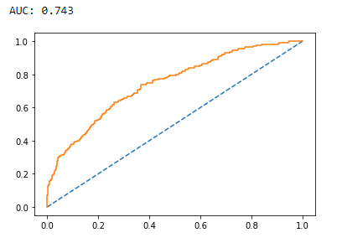
Fig 2.10 AUC Train _Logistics

  - AUC score on test data is 0.705
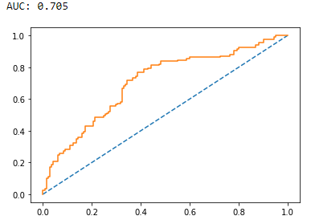
Fig 2.11: AUC test_logistics
- Confusion Report on Train data:
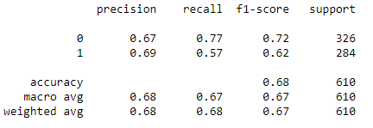
Table: 2.9: Confusion Report on Train data_Logistics
Inferences:
- For predicting employees who will not opt for package:
  - Precision – 67% of prediction of employees who will not opt for package are correct.
  - Recall: 77% of employees who will not opt for package are correctly predicted.
- For predicting employees who will opt for package:
  - Precision – 69% of prediction of employees who will not opt for package are correct.
  - Recall: 57% of employees who will not opt for package are correctly predicted.

- Overall Accuracy of the Model is 68% of total prediction are correct.
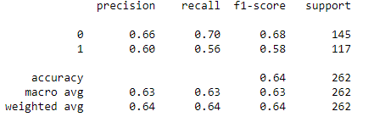
Table: 2.9: Confusion Report on Test Data_Logistics
Inferences:
- For predicting employees who will not opt for package:
  - Precision – 66% of prediction of employees who will not opt for package are correct.
  - Recall: 70% of employees who will not opt for package are correctly predicted.
- For predicting employees who will opt for package:
  - Precision – 60% of prediction of employees who will not opt for package are correct.
  - Recall: 56% of employees who will not opt for package are correctly predicted.

- Overall Accuracy of the Model is 64% of total prediction are correct.
Linear Discriminant Analysis:
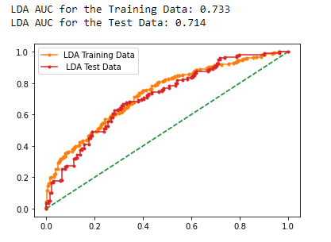
Fig 2.12 LDA AUC and ROC

- Confusion Report on Train data
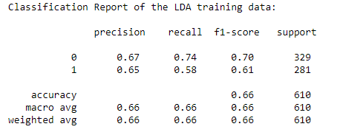
Table: 2.10: Confusion Report on Train Data_LDA
Inferences:
- For predicting employees who will not opt for package:
  - Precision – 67% of prediction of employees who will not opt for package are correct.
  - Recall: 74% of employees who will not opt for package are correctly predicted.
- For predicting employees who will opt for package:
  - Precision – 67% of prediction of employees who will not opt for package are correct.
  - Recall: 58% of employees who will not opt for package are correctly predicted.

- Overall Accuracy of the Model is 66% of total prediction are correct.

Confusion Report on Train data:
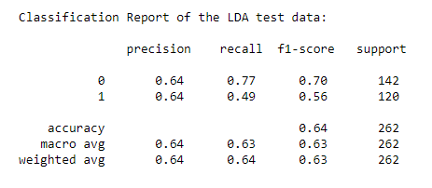
Table: 2.10: Confusion Report on Test Data_LDA

Inferences:
- For predicting employees who will not opt for package:
  - Precision – 64% of prediction of employees who will not opt for package are correct.
  - Recall: 77% of employees who will not opt for package are correctly predicted.
- For predicting employees who will opt for package:
  - Precision – 64% of prediction of employees who will not opt for package are correct.
  - Recall: 49% of employees who will not opt for package are correctly predicted.

- Overall Accuracy of the Model is 64% of total prediction are correct.

Logistics regression Model and Linear Discriminant analysis using Grid Search:
Logistics regression Model:
Confusion Report on Train data: Confusion Report on Test data:

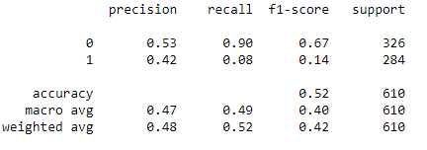
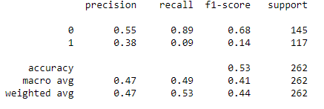

It is clear that earlier model without best grid parameters scores are high all aspects including accuracy score
Linear Discriminant Analysis:
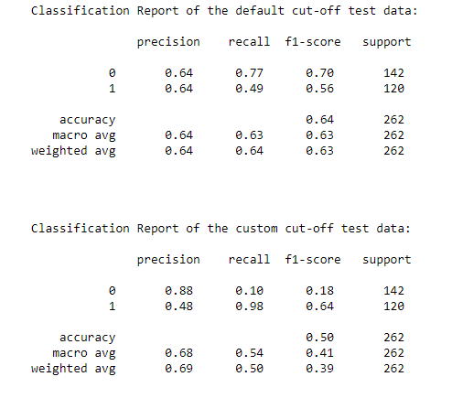
It is clear that earlier model without best grid parameters scores are high all aspects including accuracy scores.
- In this question Logistics Regression Analysis (best parameters given) and Linear Discriminant Analysis have been chosen as the recall values are more in the models without Grid Search.

Inferences:
The main objective of the model will be to accurately predict client who will opt for holiday package. Therefore recall is the most critical measure as recall identifies how many of the actual true data points are identified as true data points by the model.
Therefore, taking the recall value logistics (Best Parameters given) without Grid Search and LDA are almost giving similar result.

2.4 Inference: Basis on these predictions, what are the insights and recommendations.
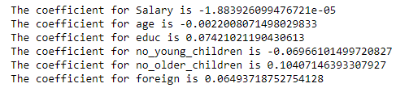
- Salaries are not criteria for individuals to opt for holiday package
- Age, Education and No young adults are the continuous variables and have a positive influence of the person opting for holiday package and one unit variable in these features increases the probability of opting for holiday package.
Model Prediction:
Both the Logistics without Grid Search and LDA are equally performing well, however Logistics Regression does not assume any specific shapes of densities in the shape of predictor variable and LDA does, we will prefer Logistics Regression to LDA.
Recommendations:
- The company should come up with the new package to attract the foreigners with new benefits and different customizable packages
- Some Add-on benefits to employees who are having higher education and do not have children
- Organization should consider some more features as these features does nor give any high parameters.

